Off-Limits Order
18th Wing, Kadena Air Base, Japan



Certified Current: 3/18/2022


DEPARTMENT OF THE AIR FORCE
PACIFIC AIR FORCES

19 March 2021

MEMORANDUM FOR ALL ACTIVE DUTY USAF PERSONNEL ON OKINAWA
ALL USAFR/ANG PERSONNEL IN TITLE 10 STATUS ON OKINAWA

FROM: 18 WG/CC

SUBJECT: Off-Limits Order

- I have received credible info1mation from the Okinawa Aimed Forces Disciplinary Control Board that the establishments and areas listed in this memorandum present conditions that adversely affect the health, safety, welfare , morale, or morals of Air Force personnel located onOkinawa and they are thus deemed off-limits.

- Order. Effective immediately, in accordance with the Okinawa Armed Forces Disciplinary Control Board's findings, the following areas are off-limits to all active duty United States Air Force milita1y members temporarily or permanently located on Okinawa. This includes members of the United States Air Force Reserve or Air National Guard components while temporarily or pe1manently located on Okinawa and in Title 10 active duty status (including those assigned to paitner organizations) assigned to any facility over which I have control or jurisdiction. The above listed personnel are prohibited from patronizing, ente1ing, visiting, or using any of the organizations, establishments, or areas listed below:

  - Bullseye, 4-16 Kitame, Chatan, Okinawa, Japan

  - Soap Land, Area 2, Tsuji District, Naha City, Okinawa, Japan

  - Ground Tobacco Shop, 2F 1-5-9 Mihama, Chatan-Cho, Okinawa, Japan.

  - OM's Herb Shop, 3-7-12 (2d Floor) Yafuso, Urasoe City, Okinawa, Japan.

  - Takahara Hotel, Adjacent to the Nakagusuku Castle in Ishado Nakagusuku Village, Okinawa, Japan.

  - Tokyo Shoten Bookstore, Highway 23 at 820-6 Kamisedo, Chatan-Cho, Okinawa, Japan.

  - Yasu lchi Bookstore, 2-1-10 Chatan, Okinawa, Japan.

  - Fantasy Space Okinawa. Located just offOkiei Odori and Kokusai Street at 17-46 Makishi 2-Chome, Naha.

  - Yoshihara Red Light District. In the Yoshihara Red Light District, establishments with a storefront that faces routes 329 or 330 are not off-limits.

  - Banana Fish, 2 Chome-20-1 Chalan, Nakagami District, Okinawa, Japan

- I also encourage all SOFA status dependents, DoD civilians, DoD-invited contractors, as well as visitors to be aware of this order and to comply with its provisions.

- Distribution of Order. This order will receive the widest possible dissemination. Kadena Air Base unit Commanders sponsoring Air Force units arriving for TDY on Okinawa will distribute this order to the TDY unit's commander or officer in charge. The 18 FSS/CC will ensure distribution to all personnel residing in lodging. The 733 AMS/CC will ensure distribution to all persom1el arriving on Kadena Air Base via the passenger tenninal.

- Consequences of Violating Order. Violations of this order constitute a violation of Article 92, UCMJ. Military members who violate this order are subject to sanctions under the Unifonn Code of Military Justice and/or administrative action, including loss of security clearance, demotion, and/or discharge from the United States Air Force.


.../..:Z
JOELL. CAREY
Brigadier General, USAF Connnander, 18th Wing

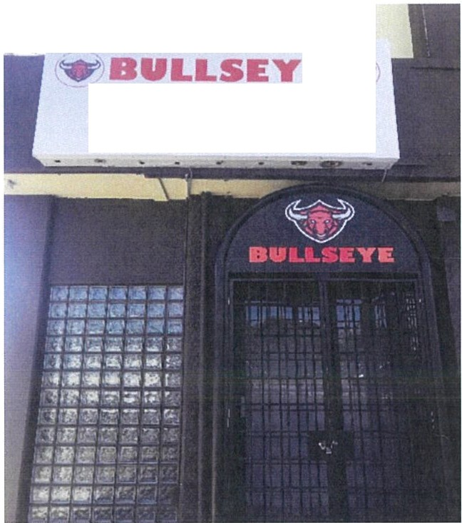
Establishment: Bullseye
Address: 4-16 Kitame, Chatan, Ok
-
D A N C I N G - K A R A O KE
1 s t Floor
C A FE - P O O L - D A R T S•

inawa,

Japan

" h la 9
ram,lyMdrt
Chat.Jn K1tomac
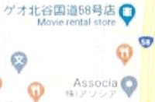
'

K AM t.

C • 9

9'

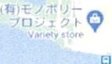
lawsor•
t,,,f,",.fff
.
9

....
- 416 K11amao Futenmo River


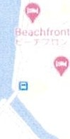
Q
TELtFC,fH.,t l"I
I sh 11 S"<>Py

Q can p fo 1l'F LIbfary

Establishment: Soap Land

Address: Area 2, Tsuji District, Naha City; it is a 3x4 block area within Area 2 consisting of 56 bathhouses. Western boundary of Soap Land is Gas Dori Street and Salada Bowling Alley. Northern boundary is Route 47. Eastern boundary is Route
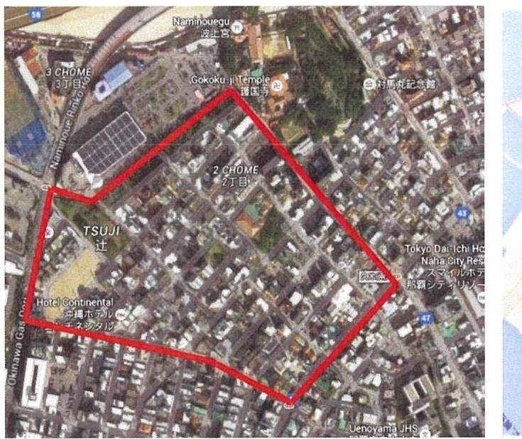
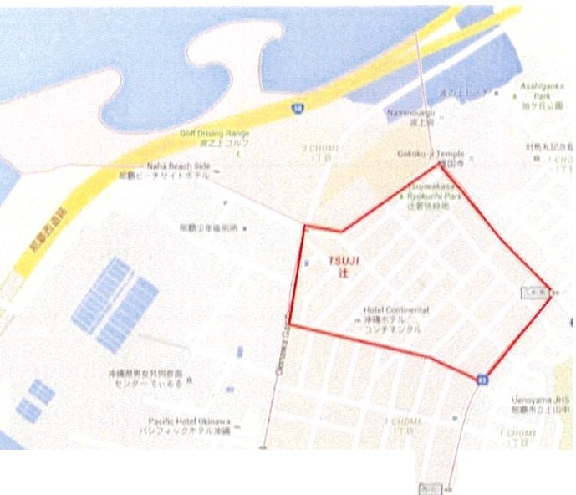
43. Southern Boundary begins at Gas and 127.668 longitude and ends at Route 43 and 127.671.
f\fl r •
..

Establishment: Ground Tobacco Shop

Address: 2F 1-5-9 Mihama, Chatan-Cho, Okinawa, Japan
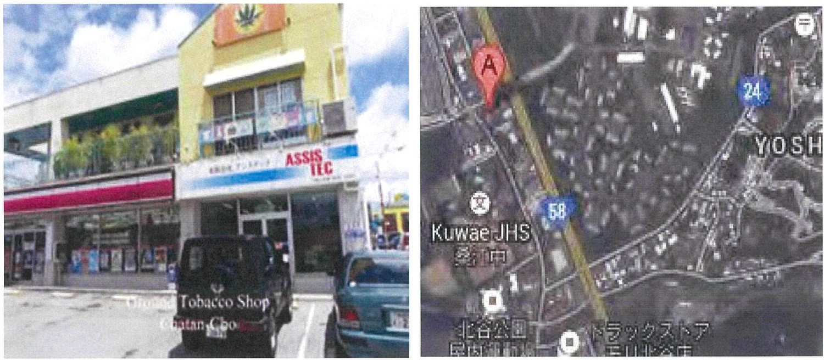

Establishment: OM' s Herb Shop

Address: 3-7-12 (Second Floor) Yafuso, Urasoe City, Okinawa, Japan
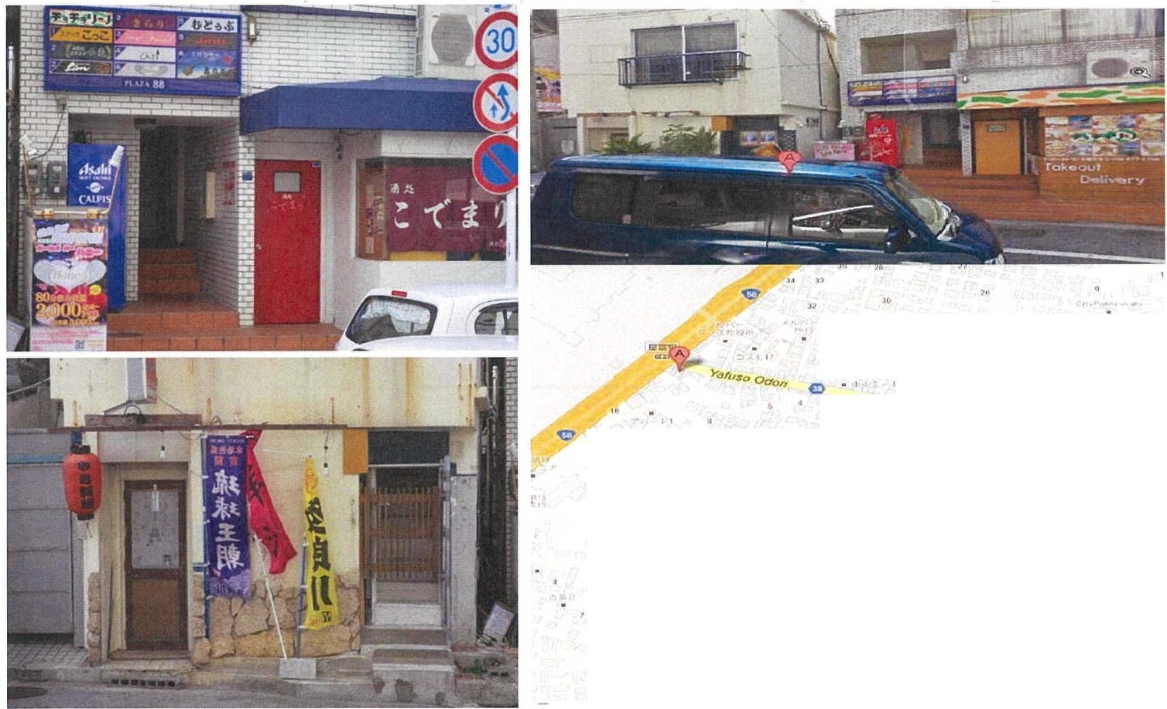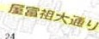
4T lal
' ,
Ya fu so
ti;
113 -r Q
" -
C
" '
2 T lel
..
,, _.,..
...
•
r:
.,.
lt'
lt'
N• k• r'ltSh • e 1em entary Ceho ol
N e l<• rua ht Jr HtQh SchOOI
!
,I,- ,t f' c- t:.

Establishment: Takahara Hotel

Address: Next to the Nakagusuku Castle in Ishado Nakagusuku Village
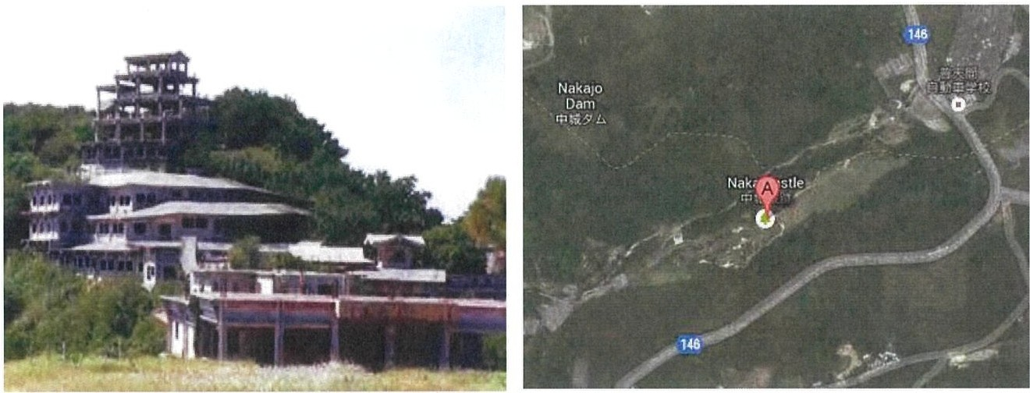
Establishment:Tokyo Shoten Bookstore

Address: Highway 23 at 820-6 Kamisedo, Chatan-Cho, Okinawa, Japan
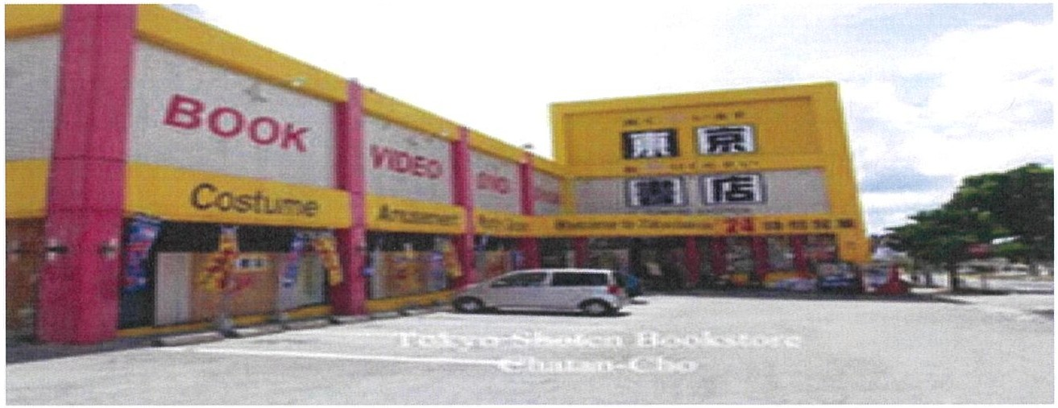

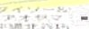
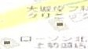
, ' Cl
T ra ffi c


- I • I
- I I.

I ,
I ,.. r., ii '
' '
..., -
...

.
'
'

.. • I
•

K u w a e

I ~ o
:s':c

C h e l • nd o ,n ,
E. l e m e n to ry
School
I I ,

Establishment: Yasu Ichi Bookstore
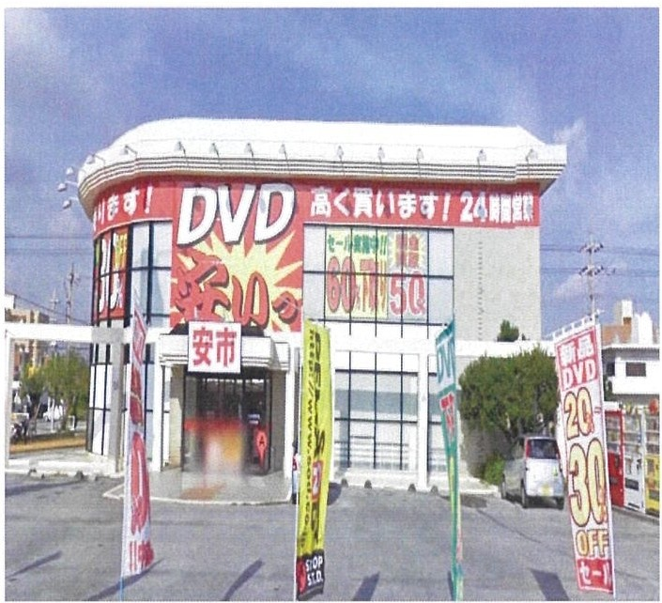
Address: 2-1-10 Chatan, Okinawa, Japan

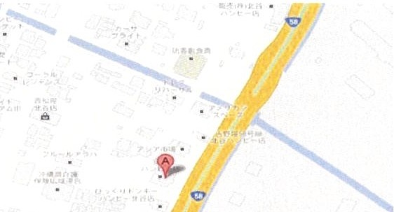
Chala n

•• 2Tlel a



Establishment: Fantasy Space Okinawa
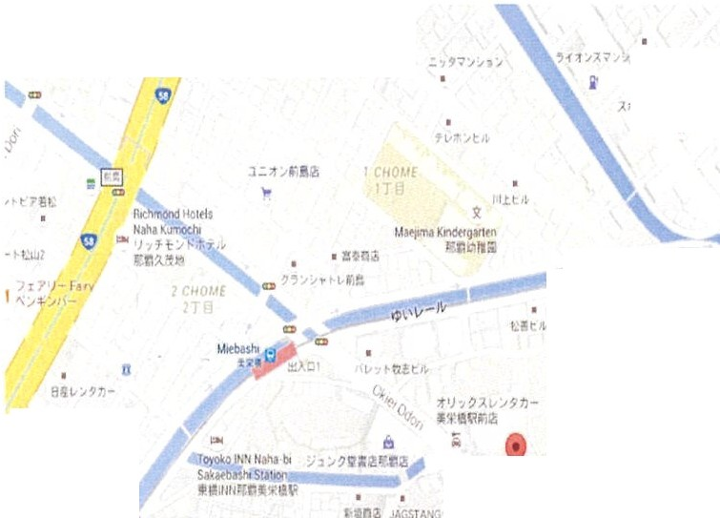
Address: 17-46 Makishi 2-Chome, Naha, Okinawa, Japan
...
fklutt ..-inNat.a1A.,,,a t,;-•.,...-t,., r11 OJ 8 11'.M I •
(/\-I I• I
,,a
""lt? ,t
- l l'll'!!l!t;

D
V.. ,j D
,- t
- 17f ?t',
-11 -, , . ,, ,.,6
' f f ,n I
ii ;,,r;
_ )- J -c- 7, ,I I
l Ar«•Y •
,. 1 r ,11,1"'I'
,,
.,, ,,
c;
ll.
Fantasy
$pact
Okl n1 w1
S:-"iif
t
"
"'

,.,.

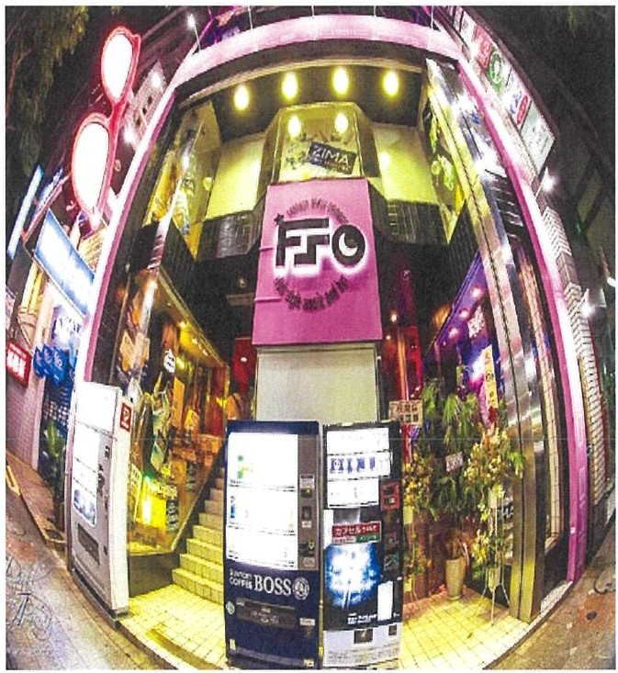
Sl9,I ::':,,..

ll:>ittzu 1!'1.) v)M "I
Cl

•;t
Cl
1 n , ,. i;..,

' !It,
..
0 'it 11• '!
t"t!J-

I t A-;t $'Ii
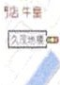
11 .,;

, , ; .. L•"' l:f I
I Q f1•• 7 ;..,:,'1 t ll 1tt

,. It,...I

D ' '<
rt3
!!

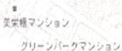
J TE ,- ,. •, ,:;
unde rcr ound
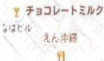
tiD

I •.._f ,'tJ,.,,!:



l ,o<l fJolC.•1 w
..
i l!P►7-

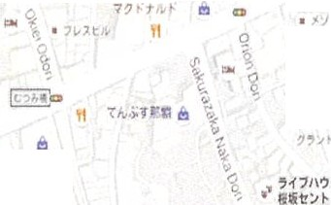
I.Ct.. • p
7 '} t I-­
It
l!"il"t1
Q
llon°'-'.•"
KOkn11St1tt l lhop
• / • .f:t,- T
a;,.11,1a

KUAIOJI
iil:'i
Tl
;.1-1,.,,'} :. ,
,..,:►'
I
•t...,J./11,. 7 , JIQ

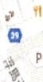

t t .. ; n 2i ,

•

Establishment: Yoshihara Red Light District

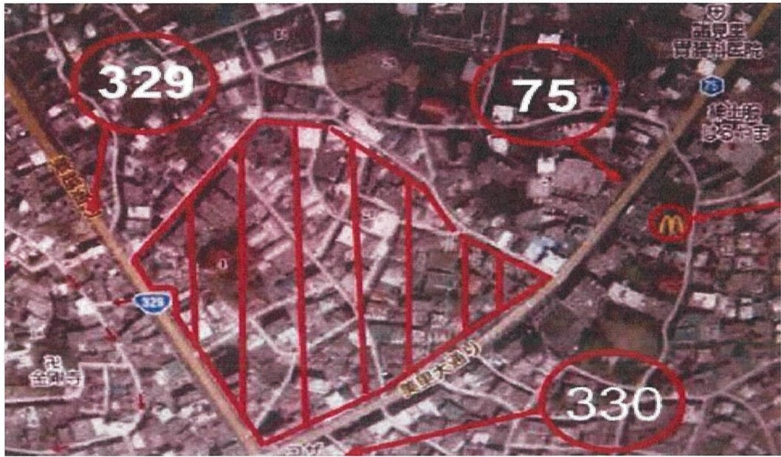
Address: In the Yoshihara Red Light District, establishments with a storefront that faces 329 or 330 are not off-limits.

Establishment: Banana Fish

Address: 2 Chome-20-1 Chatan, Nakagami District, Okinawa, Japan

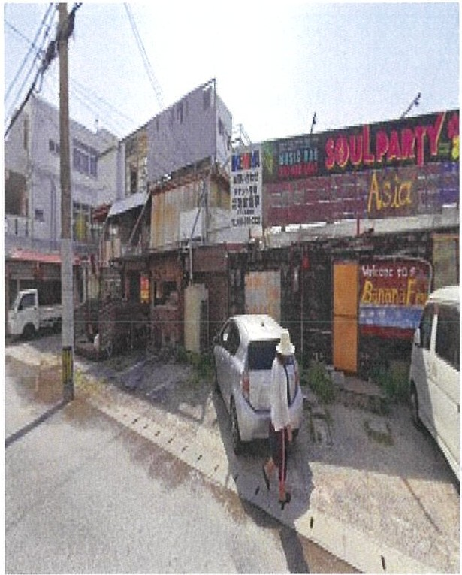
nse t Be a. ch Se aw·aII'
ll e '.Jlil-tt .,,
- I t-t - 7
T K1latama ESQ
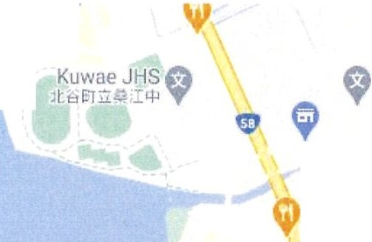
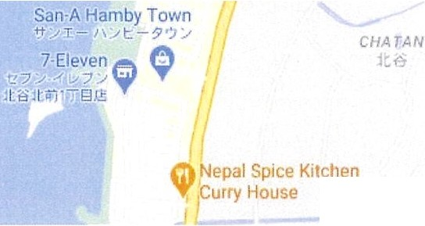
I t:il;.1li t l. 111 T

Stairway to He,
)..,,"?T-t-?-"

Ke·f'l , 8u11 to 1, uck

B anana Fish
llurnto resta rant
m>
Klll111 Eler
'le')
? ')-

13 ,,.,,, d·1•1f> 11ome OMURA

CIIA.TAN
Le
'
If Camp foster (Gate
Blkkuri Donkey 3) Firehouse Gate
rr.J ·,<. ') , ,jc,
\ / t. - . 1 t,,

Camp Fest,

F1 rten ma 1•••

